**SharePoint File Viewer PCF Control**

**Overview**

The SharePoint File Viewer is a custom Power Apps Component Framework (PCF) control designed to display and manage files within SharePoint document libraries. It provides a modern, intuitive interface for viewing and uploading files to specific SharePoint folders directly from within Power Apps applications.

**Main Functionality**

1. **File Display**: Presents files from a SharePoint folder in a clean, sortable FluentUI DetailsList with the following information:
   * Visual file type indicators (icons)
   * File name
   * Last modified date and time
   * File size (formatted in appropriate units)
   * Modified by user
2. **Drag & Drop File Upload**: Enables users to upload files to SharePoint by simply dragging and dropping them into the control area, eliminating the need to navigate to SharePoint separately.
3. **Filtering**: Allows users to quickly find files by typing in the filter field, which searches across file names and modified by fields.
4. **Sorting**: Offers the ability to sort files by any column (name, date, size, modified by) to help users organize and find content.
5. **Direct File Upload**: Includes an upload button that lets users select files from their local device to upload to the SharePoint folder.
6. **Refresh Capability**: Provides a refresh button to update the file list and reflect any changes made by other users.

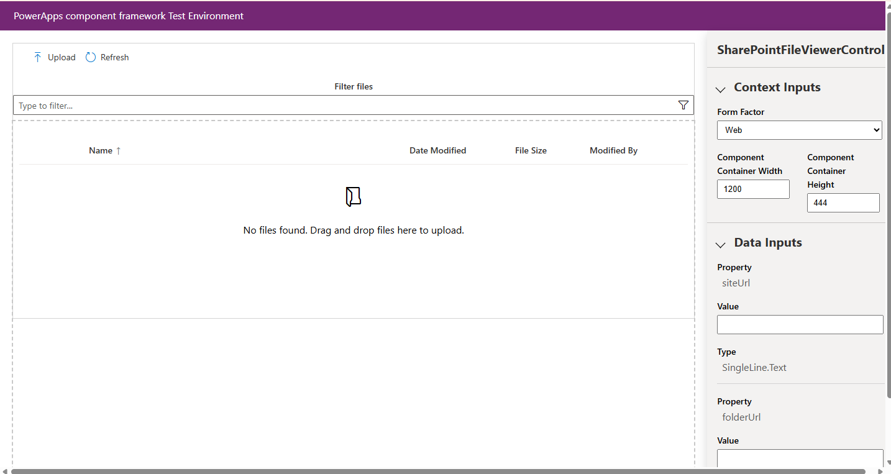

To **enable code components in Power Apps using PCF (PowerApps Component Framework)**, you need to ensure a few settings are properly configured both in your environment and app. Here’s a full breakdown:

**✅ 1. Enable Code Components in Environment**

For **Model-Driven Apps**, code components (PCF controls) must be explicitly enabled in the environment.

**Steps:**

1. Go to **Power Platform Admin Center**: <https://admin.powerplatform.microsoft.com>
2. Select your **Environment**.
3. Click **Settings** (under the gear icon or directly from the left panel).
4. Navigate to:  
   **Product > Features**  
   or  
   **Features > Power Apps component framework**
5. Toggle **“Power Apps component framework for canvas apps”** and/or **“Power Apps component framework for model-driven apps”** to **On**.
6. Click **Save**.